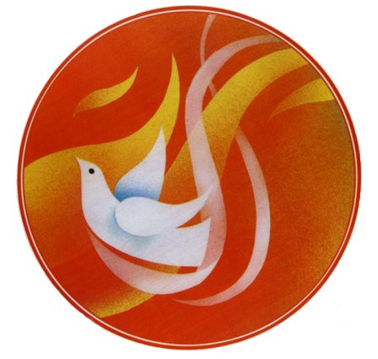
Transfiguration Catholic Church
Adult Confirmation 2022
Preparation Classes
Mass at 6:30 p.m.
Class at 7:00 p.m.

Date | Topic | Facilitator
April 21 | Morality | Bill Garrity
April 28 | Basics of the Bible | Donald Perez
May 5 | Faith, Church, Community | Tracy Turpin
May 12 | Prayer and Spirituality | Bev Sauer
May 19 | Sacraments | Mike Paula
May 26 | The Trinity | Marie LaSalle
June 2 | Reflection/Rehearsal | Cindy McFadden
June 5 | Sacrament of Confirmation  11:00 a.m. Pentecost Mass
June 9 | Mission | Cindy McFadden

